|  |  |  |
| --- | --- | --- |
| **Student Name** |  | **Student Number** |
| Akriti Kumari Dev | 23329584 |

**Portfolio Introduction**

**Workshop Activities 50% Weighting**

**Mini Project 50% Weighting**

**This completed portfolio will need submitting to Canvas by the due date.**

**Questions please email**

**Dr Sarah Slater**

**s.i.slater@wlv.ac.uk**

**Portfolio**

Contents

Workbook 1 ............................................................................................................................................ 4

Activity 1.1: Actual voltage across 5V breadboard pins. ....................................................................... 4

Activity 1.2: Actual voltage across 3.3V breadboard pins. ..................................................................... 4

Activity 1.3: Potential Divider Calculations ........................................................................................... 5

Activity 1.4: 3V Calculations from either the 5V supply or 3.3V supply ................................................. 5

Activity 1.5: Voltage Divider circuit readings from Breadboard circuit. ................................................ 6

Activity 1.6: LED Circuits ..................................................................................................................... 6

Activity 1.7: Current Measurement ..................................................................................................... 7

Activity 1.8: Fritzing for 4 switches & LEDS .......................................................................................... 9

Activity 1.9: Fritzing for Number 0-7 ..................................................................................................... 10

Workbook 2 .......................................................................................................................................... 11

Activity 2.1: LED Flashing to show decimal number 63 as binary. ....................................................... 11

Activity 2.2: 4 LED’s for counting up in binary from 0 to 15. ............................................................... 12

Activity 2.3: Traffic Lights ................................................................................................................... 18

Workbook 3 .......................................................................................................................................... 21

Activity 3.1: Circuit Diagram of Button & LED ..................................................................................... 21

Activity 3.2: 3 Switches & Led ............................................................................................................ 23

Activity 3.3: 8 Buttons & LEDs (SWITCH STATEMENTS) ....................................................................... 26

Workbook 4 .......................................................................................................................................... 29

Activity 4.1: Serial Port....................................................................................................................... 29

Activity 4.2: Serial Port binary to decimal ........................................................................................... 32

Activity 4.3: Calibrating Analogue Information ................................................................................... 36

Activity 4.4: Temperature Sensor & Serial Port .................................................................................. 39

Workbook 5 .......................................................................................................................................... 42

Activity 5.1: RGB Led and switches ..................................................................................................... 42

Activity 5.2: Distance Sensor .............................................................................................................. 45

Activity 5.3: 1602 LCD Display ............................................................................................................ 48

Workbook 6 .......................................................................................................................................... 53

Activity 6.1: PWM .............................................................................................................................. 53 Workbook 7 .......................................................................................................................................... 55

Activity 7.1: 2 Arduinos – using Digital Pins ........................................................................................ 55

Activity 7.2: 2 Arduinos – using Serial I/O ........................................................................................... 57

Workbook 8 .......................................................................................................................................... 59

Activity 8.1: Stepper Motor Circuit Diagram ....................................................................................... 59

Activity 8.2: 2 Stepper Motors ........................................................................................................... 61

Workbook 9 .......................................................................................................................................... 62

Activity 9.1: Windscreen Wiper Code using Servos & Temperature Sensor ......................................... 62

Individual Project (50%) ......................................................................................................................... 64

Rationale ........................................................................................................................................... 64

Timescales ......................................................................................................................................... 64

Equipment ......................................................................................................................................... 64

The Project ........................................................................................................................................ 64

Step 1 produce adetailed description of your project. .................................................................... 64

Step 2 Circuit Diagram&Fritzing Schematic .................................................................................... 64

Step 3 A Program ........................................................................................................................... 65

Step 4 Testing ................................................................................................................................ 65

Step 5 Conclusions ......................................................................................................................... 65

Layout ........................................................................................................................................... 65

Marking ......................................................................................................................................... 65

All sections carry equal marks. ............................................................................................................... 65

|  |  |
| --- | --- |
| If you prefer, you may use Tinkercad to show a component layout, rather than a circuit Diagram in | |
| Fritzing or other circuit design software, though a circuit diagram is more useful as this is what you | |
| would most likely see if you were working on embedded systems. |  |

# Workbook 1

## Activity 1.1: Actual voltage across 5V breadboard pins.

5.2V

## Activity 1.2: Actual voltage across 3.3V breadboard pins.

3.3V

Explain in around 100 words why you think the value read by a multi meter on a circuit, may be different to a simulator value such as TinkerCad.

The value may change based on variables like as internal resistance, temperature, and tolerance

(occurring during the manufacturing process). As a result, tolerance can be found in the physical form. For our convenience, we take use of excellent situations. When conditions are perfect, TinkerCad works. As a result, in TinkerCad we frequently get ideal values like 5V in the example above. In reality, we frequently get results that are either little higher or slightly lower than

optimal, like 5.2.

If the read value is 4.84V on a 5V supply, what would be a sensible tolerance to quote, explain your answer.

Tolerance = (L-R)/L*100

Tolerance = =(4.84 − 5)/5 × 100%

= (−0.16)/5 × 100%

= −3.2%

From calculation, we get the value of tolerance to be 3.2%. So the sensible tolerance to quote is +- 3.2%.

Both resistors are connected in series that’s why voltage is divided..

## Activity 1.3: Potential Divider Calculations

Show the working on how you achieved 2.5V

|  |
| --- |
| Starting out, we apply a 5V voltage. To create a 2.5V voltage drop, we use a potential divider. We serially connect the resistors of the two 220-ohm resistors to measure the voltage between them on either side of the battery.  V=IR  V1 = IR1 & V2 = IR2  NOW,  IR = IR1 + IR2  R = R1 + R2 |

## Activity 1.4: 3V Calculations from either the 5V supply or 3.3V supply

Here, R1=220Ω Rt=R1+R2 (Total Resistance)

V= 5V (Taking 5V)

Vd=Voltage drop=3V

After Calculation we get,

220+R2= 366.67Ω [here 366.67-220=146.67 The value of second resistance(R2) is 147Ω.

## Activity 1.5: Voltage Divider circuit readings from Breadboard circuit.

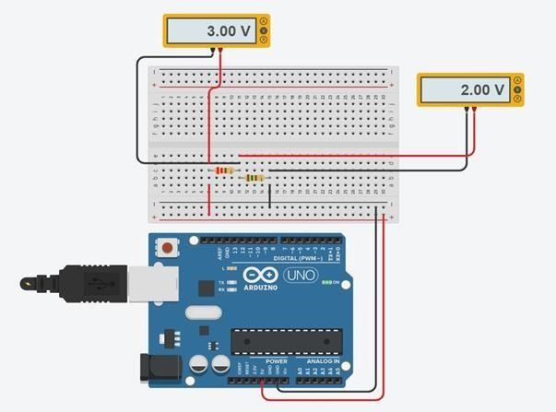

## Activity 1.6: LED Circuits

Each resistor Value

|  |  |  |  |
| --- | --- | --- | --- |
| |  | | --- | | 220 ohm | | |  | | --- | | 220 ohm | |

Total resistance Calculation

Here,

1/R=1/R1+1/R2

=1/220+1/220

=2/220

=1/110

Measured Resistance

110 ohm

If measured resistance is not the same, why not? If you simulated this, why might the real value be different.

Due to device tolerance, the measured resistance displayed on multimeters and electrical equipment may not reflect the precise resistance of the object being tested. The allowed range of departure from the actual value is what is meant by tolerance. Additionally, the resistance of the wires used to link the measurement device to the multimeter or other measuring tools may have an impact on the measured resistance. Therefore, there is a chance that the measured resistance will differ from the object's actual resistance.

## Activity 1.7: Current Measurement

Calculation of current flowing into LED

61.5 A

Actual measured value of current

60 A

Why might they be different?

In real-world situations, it's possible that the estimated or ideal value of a measurement used for computations won't match the actual value. This is because a number of factors can change the measurement value, such as tolerance, which is brought on by the substance being measured's natural fluctuation. The measurement value may also be affected in various ways by additional factors like time, temperature, and humidity.

## Activity 1.8: Fritzing for 4 switches & LEDS

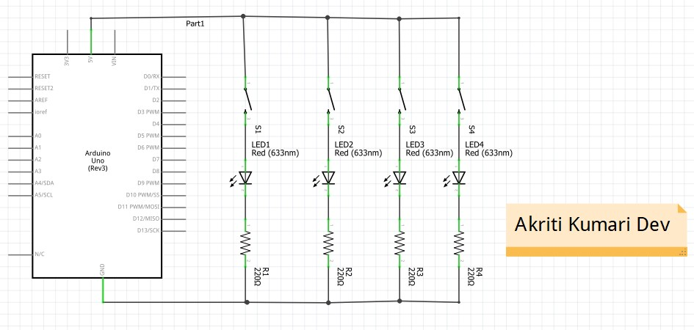

# Activity 1.9: Fritzing for Number 0-7

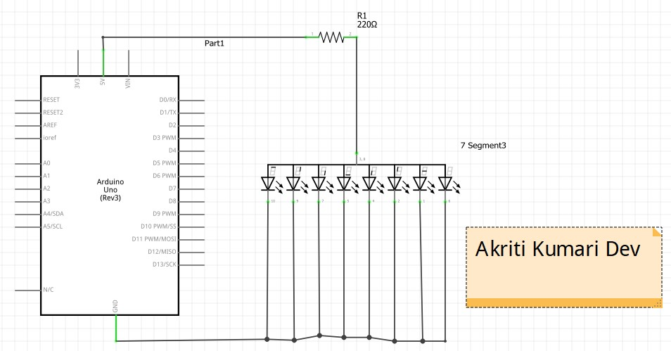

# Workbook 2

## Activity 2.1: LED Flashing to show decimal number 63 as binary.

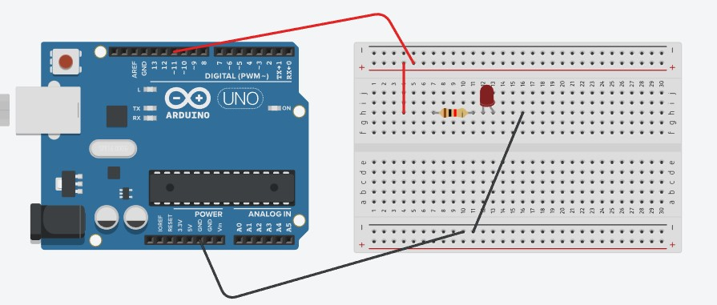

63 as binary, including working

Copy & Post your code with a suitable comment at the top of code with your name & student number ☺

|  |
| --- |
| // C++ code  // Akriti Kumari Dev // Student Id- 2329584  int i = 0; int counter; void setup()  {  pinMode(11, OUTPUT);  }  void loop(){  //binary for 63 is 111111 the led blinks for 6 times and stops itself for (counter = 0; counter < 6; ++counter) { digitalWrite(11, HIGH); delay(1000); // Wait for 1000 millisecond(s) digitalWrite(11, LOW); delay(1000); // Wait for 1000 millisecond(s)  exit(0)  }  } |

## Activity 2.2: 4 LED’s for counting up in binary from 0 to 15.

Fritzing Circuit diagram for Step 4 i.e. 4 LEDs

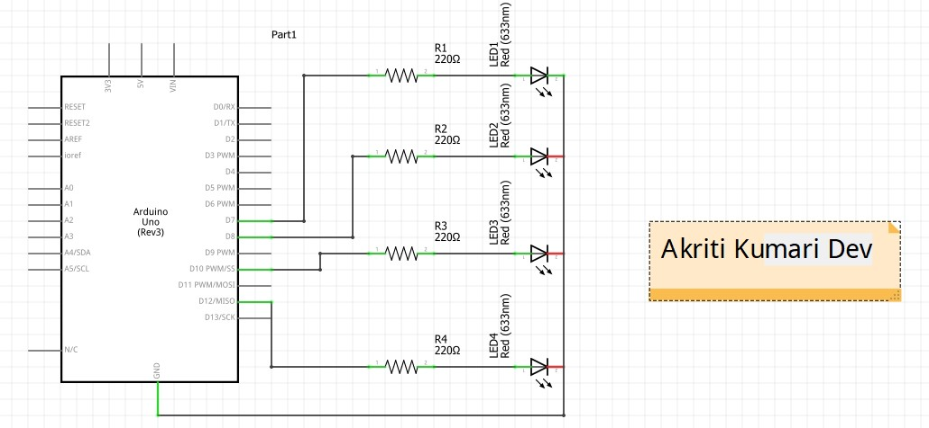

Arduino Program for Step 4 i.e. 4 LEDs

// C++ code

// Akriti Kumari Dev

// Student ID - 2329584

// this code will show the binary count from 0-15 serially.

int led1=12; int led2=10; int led3=8; int led4=7;

void setup()

{

pinMode(led1, OUTPUT); pinMode(led2, OUTPUT); pinMode(led3, OUTPUT); pinMode(led4, OUTPUT);

}

void loop()

{

//for binary 0 digitalWrite(led1,LOW); digitalWrite(led2,LOW); digitalWrite(led3,LOW); digitalWrite(led4,LOW); delay(1000);

//for binary 1

digitalWrite(led1,LOW); digitalWrite(led2,LOW); digitalWrite(led3,LOW); digitalWrite(led4,HIGH); delay(1000);

//for binary 2 digitalWrite(led1,LOW); digitalWrite(led2,LOW); digitalWrite(led3,HIGH); digitalWrite(led4,LOW); delay(1000);

//for binary 3 digitalWrite(led1,LOW); digitalWrite(led2,LOW); digitalWrite(led3,HIGH); digitalWrite(led4,HIGH); delay(1000);

//for binary 4 digitalWrite(led1,LOW); digitalWrite(led2,HIGH); digitalWrite(led3,LOW); digitalWrite(led4,LOW); delay(1000);

//for binary 5 digitalWrite(led2,HIGH); digitalWrite(led3,LOW); digitalWrite(led4,HIGH); delay(1000);

//for binary 6 digitalWrite(led1,LOW); digitalWrite(led2,HIGH); digitalWrite(led3,HIGH); digitalWrite(led4,LOW); delay(1000);

//for binary 7 digitalWrite(led1,LOW); digitalWrite(led2,HIGH); digitalWrite(led3,HIGH); digitalWrite(led4,HIGH); delay(1000);

//for binary 8 digitalWrite(led1,HIGH); digitalWrite(led2,LOW); digitalWrite(led3,LOW); digitalWrite(led4,LOW); delay(1000);

//for binary 9 digitalWrite(led1,HIGH); digitalWrite(led3,LOW); digitalWrite(led4,HIGH); delay(1000);

//for binary 10 digitalWrite(led1,HIGH); digitalWrite(led2,LOW); digitalWrite(led3,HIGH); digitalWrite(led4,LOW); delay(1000);

//for binary 11 digitalWrite(led1,HIGH); digitalWrite(led2,LOW); digitalWrite(led3,HIGH); digitalWrite(led4,HIGH); delay(1000);

//for binary 12 digitalWrite(led1,HIGH); digitalWrite(led2,HIGH); digitalWrite(led3,LOW); digitalWrite(led4,LOW); delay(1000);

//for binary 13 digitalWrite(led1,HIGH); digitalWrite(led2,HIGH);

digitalWrite(led4,HIGH); delay(1000);

//for binary 14 digitalWrite(led1,HIGH); digitalWrite(led2,HIGH); digitalWrite(led3,HIGH); digitalWrite(led4,LOW); delay(1000);

//for binary 15 digitalWrite(led1,HIGH); digitalWrite(led2,HIGH); digitalWrite(led3,HIGH); digitalWrite(led4,HIGH); delay(1000);

}

### Activity 2.3: Traffic Lights

Fritzing Circuit diagram for traffic light

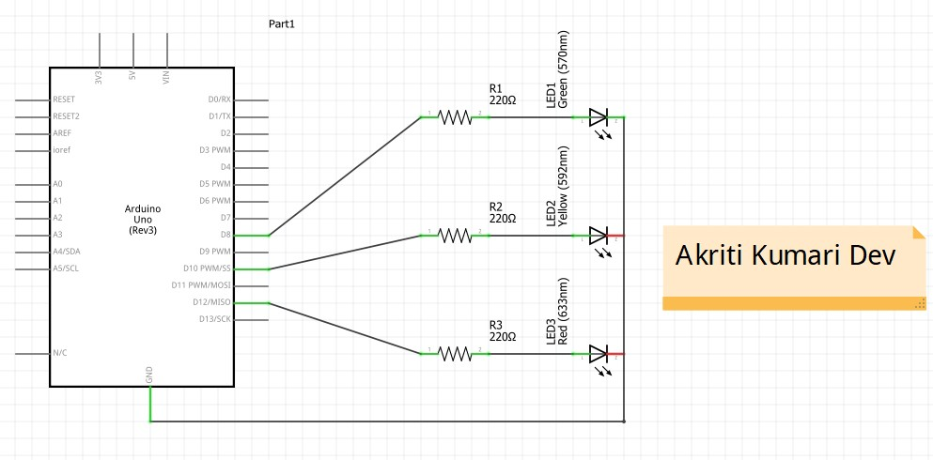

Arduino Program for traffic light

//Akriti Kumari Dev //2329584

int redLight = 8; int yellowLight = 10; int greenLight = 12;

void setup() {

pinMode(redLight, OUTPUT); pinMode(yellowLight, OUTPUT); pinMode(greenLight, OUTPUT);

}

void loop() { digitalWrite(redLight, HIGH); delay(5000);

digitalWrite(yellowLight, HIGH); delay(2000);

digitalWrite(redLight, LOW); digitalWrite(yellowLight, LOW); digitalWrite(greenLight, HIGH); delay(5000);

digitalWrite(greenLight, LOW); digitalWrite(yellowLight, HIGH); delay(2000);

digitalWrite(2000, LOW);

}

Workbook 3

### Activity 3.1: Circuit Diagram of Button & LED

Fritzing Diagram

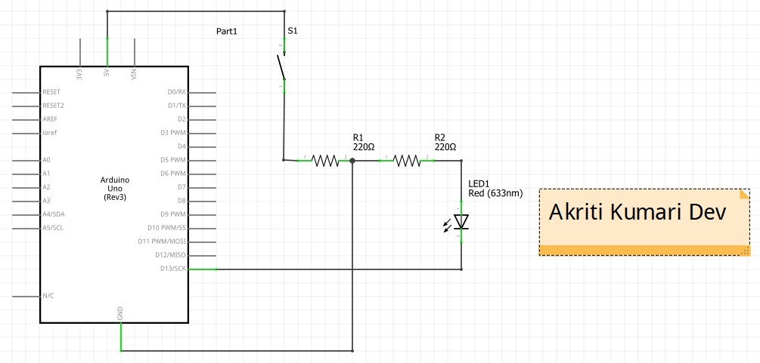

### Activity 3.2: 3 Switches & Led

Fritzing Diagram

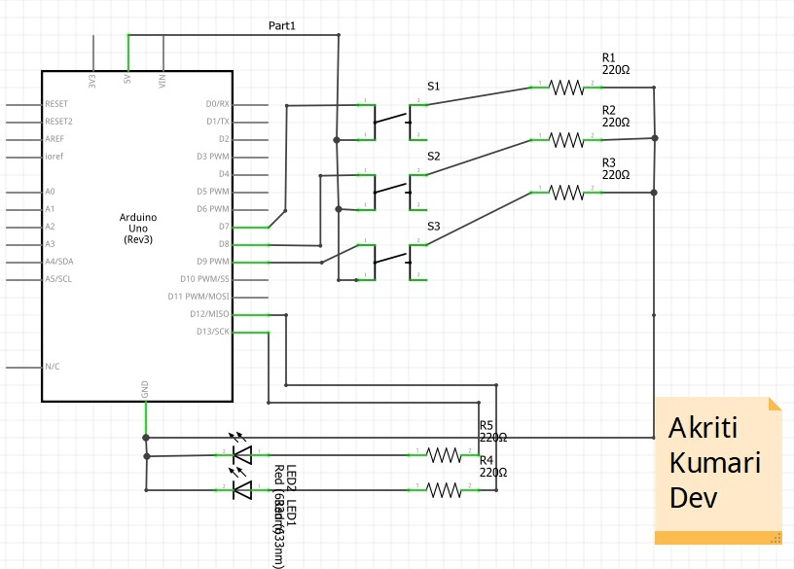

Arduino Program

//Akriti Kumari Dev //2329584

int switchPin1 = 2; int switchPin2 = 3; int switchPin3 = 4;

int gled = 12; int rled = 13;

void setup() { pinMode(switchPin1, INPUT); pinMode(switchPin2, INPUT); pinMode(switchPin3, INPUT);

pinMode(gled, OUTPUT); pinMode(rled, OUTPUT);

}

void loop() { if (digitalRead(switchPin1) == HIGH) { digitalWrite(gled, HIGH); delay(1000); digitalWrite(gled, LOW);

}

if (digitalRead(switchPin2) == HIGH) { digitalWrite(rled, HIGH); delay(2000); digitalWrite(rled, LOW);

}

if (digitalRead(switchPin3) == HIGH) { digitalWrite(gled, HIGH); delay(3000); digitalWrite(gled, LOW);

}

}

## Activity 3.3: 8 Buttons & LEDs (SWITCH STATEMENTS)

Fritzing Diagram

Arduino Program

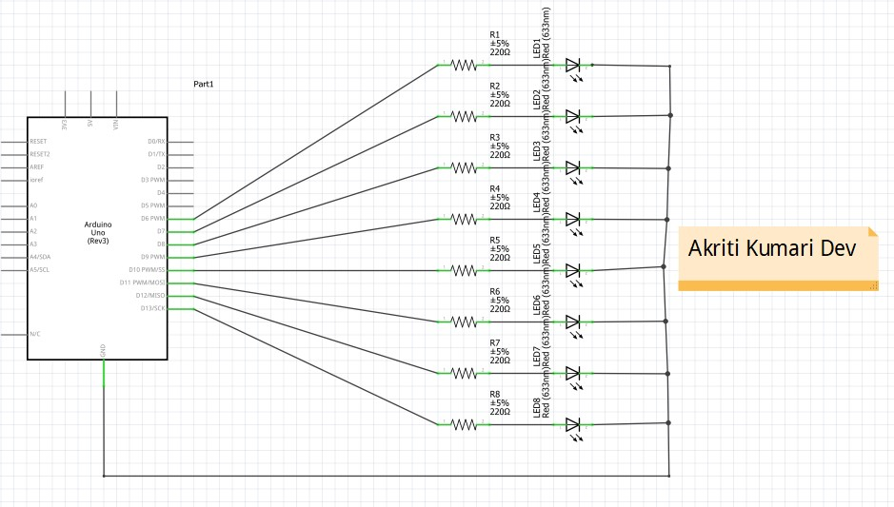

//Akriti Kumari Dev

//2329584

// C++ code

//

int led[8]={6,7,8,9,10,11,12,13}; int value=255; void setup()

{ int i; for (i=0;i<8;i++)

{

pinMode(led[i], OUTPUT);

}

}

void loop()

{

displayOutput(value);

}

void displayOutput(int value) {

for (int i = 0; i < 8; i++) { if (bitRead(value, i) == 1) { digitalWrite(led[i], HIGH); } else {

digitalWrite(led[i], LOW);

}

}

}

Workbook 4

### Activity 4.1: Serial Port Fritzing Diagram

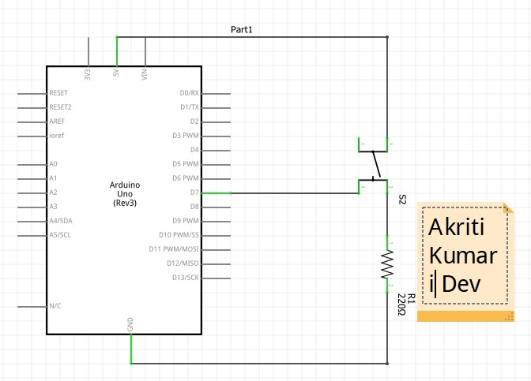

Arduino Program

|  |
| --- |
| //Akriti Kumari Dev  //2329584  // C++ code  // int bpin=13; void setup()  {  Serial.begin(9600);  }    void loop()  {  if(digitalRead(bpin)==HIGH)  {  Serial.print("Akriti Kumari Dev "); Serial.println("2329584"); delay(1000);  }  } |

Screen Shot of Serial

Port

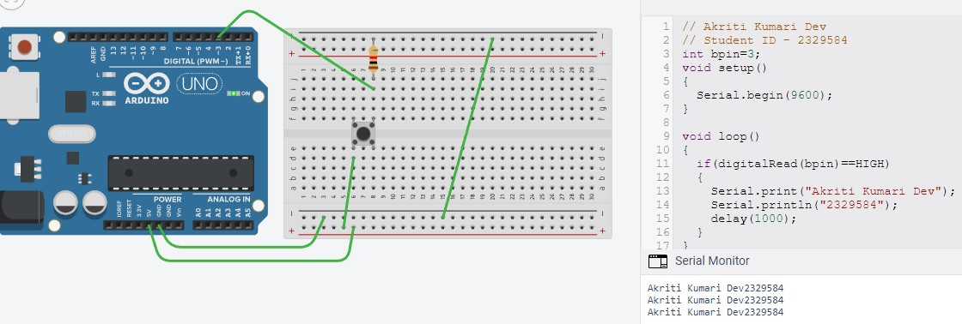

### Activity 4.2: Serial Port binary to decimal

Code

//Akriti Kumari Dev //2329584

int switchInput[8] = {6, 7, 8, 9, 10, 11, 12, 13};

int i;

void setup()

{ for (i = 0; i < 8; i++)

{

pinMode(switchInput[i], INPUT);

}

Serial.begin(9600);

}

void loop()

{ int n; float result = 0; for (i = 0; i < 8; i++)

{

int switchState = digitalRead(switchInput[i]); if (switchState == HIGH)

{ n = 1;

}

else

{ n = 0; }

result = result + n * pow(2, i);

}

Serial.print("The decimal representation is "); Serial.println(result); delay(1000);

}

Screen Shot of Serial Port

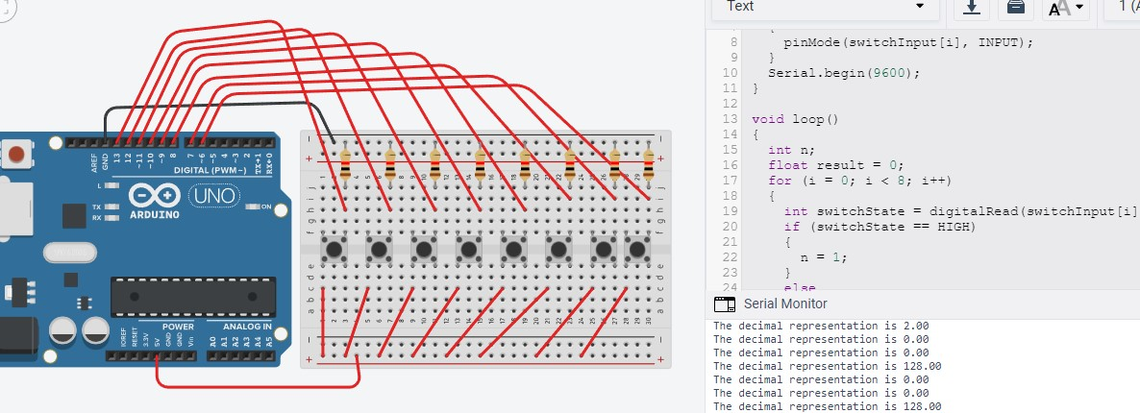

### Activity 4.3: Calibrating Analogue Information

Code

//Akriti Kumari Dev

//2329584

// C++ code

// int buttonPin=11; void setup()

{

pinMode(buttonPin,INPUT);

Serial.begin(9600);

}

void loop()

{

int buttonValue=digitalRead(buttonPin); if(buttonValue==HIGH)

{

int value=analogRead(A0);

Serial.println(value);

float voltage=value*(5.0/1023.0);

Serial.print("The corresponding voltage is "); Serial.println(voltage); delay(1000); float resistance=voltage*250.0/5.0;

Serial.print("The corresponding resistance is "); Serial.println(resistance); delay(1000);

}

}

Pot Resistance Clockwise

0 K ohm

Pot Resistance Anti-clockwise

249.80 K ohm

Sample of Values

Pot Resistance against Voltage change

|  |  |
| --- | --- |
| Pot Resitance | Voltage Measured |
| 138.56 K ohm | 2.77 V |
| 96.77 K ohm | 1.94 V |
| 170.33 K ohm | 3.41 V |
| 114.61 K ohm | 2.29 V |
| 163.49 K ohm | 3.27 V |

Screen Shot of Meaningful Serial Port Output, not just numbers

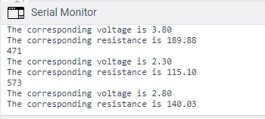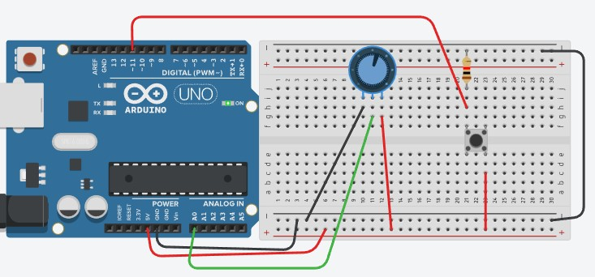

### Activity 4.4: Temperature Sensor & Serial Port

Code - Centigrade to Serial port, but when button Pressed Fahrenheit Displayed Instead

|  |
| --- |
| //Akriti Kumari Dev  //2329584 void setup()  {  pinMode(A0, INPUT);  Serial.begin(9600);  }  void loop()  {  float ana = analogRead(A0); float degreeC = ana*500/1023; float degreeF = (degreeC * 1.8)+32;  Serial.print("The temperature is ");  Serial.print(degreeF);  Serial.println(" degree Fahrenheit."); delay(5000);  } |

Screen Shot of Serial Port

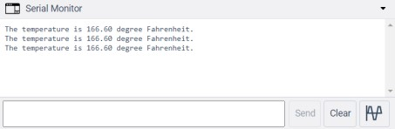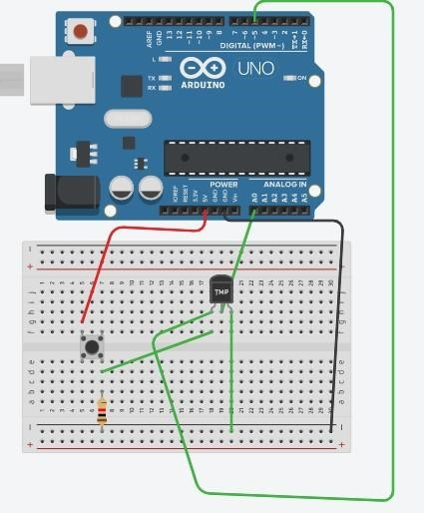

# Workbook 5

### Activity 5.1: RGB Led and switches

Fritzing Diagram

Arduino Program

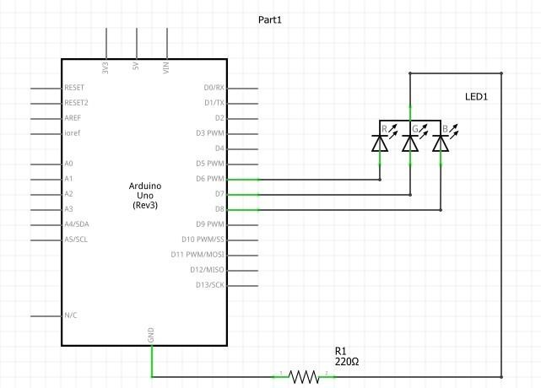

//Akriti Kumari Dev

//2329584

// C++ code

// int rled= 10; int bled= 11; int gled= 12; int rpin= 2; int bpin= 3; int gpin= 4; void setup()

{

pinMode(rled, OUTPUT); pinMode(bled, OUTPUT); pinMode(gled, OUTPUT); pinMode(rpin, INPUT); pinMode(bpin, INPUT); pinMode(gpin, INPUT);

}

void loop()

{

if (digitalRead(rpin)==HIGH)

{

digitalWrite(rled, LOW);

}

else

{

digitalWrite(rled, HIGH);

}

if (digitalRead(bpin)==HIGH) {

digitalWrite(bled, LOW);

} else

{

digitalWrite(bled, HIGH);

}

if (digitalRead(gpin)==HIGH)

{

digitalWrite(gled, LOW);

} else

{

digitalWrite(gled, HIGH);

}

}

### Activity 5.2: Distance Sensor Arduino Code

//Akriti Kumari Dev

// Student Id- 2329584 // C++ code int echoPin=7; int triggerPin=11; void setup()

{

pinMode(triggerPin, OUTPUT); pinMode(echoPin, INPUT); Serial.begin(9600);

}

void loop()

{

int highPulseDuration; int calculateDistanceCm;

//set the triggerpoint to low before setting digitalWrite(triggerPin, LOW); delayMicroseconds(5);

//create 10 seconds pulse on the trig pin digitalWrite(triggerPin, HIGH); delayMicroseconds(10);

//set the pin to low to end the pulse digitalWrite(triggerPin, LOW);

//read the duration of the highpulse on the echo pin highPulseDuration=pulseIn(echoPin,HIGH);

//calculating the distance calculateDistanceCm = highPulseDuration*0.034/2;

//sound wave divided by 2 (go and back)

//Displays the distance on the serialpulseIn Monitor

Serial.print("Calculated distance: ");

Serial.println(calculateDistanceCm);

Serial.println(" cm"); delay(1000);

}

Take a picture of your distance sensor and include it here, please reduce the size and quality as it will be

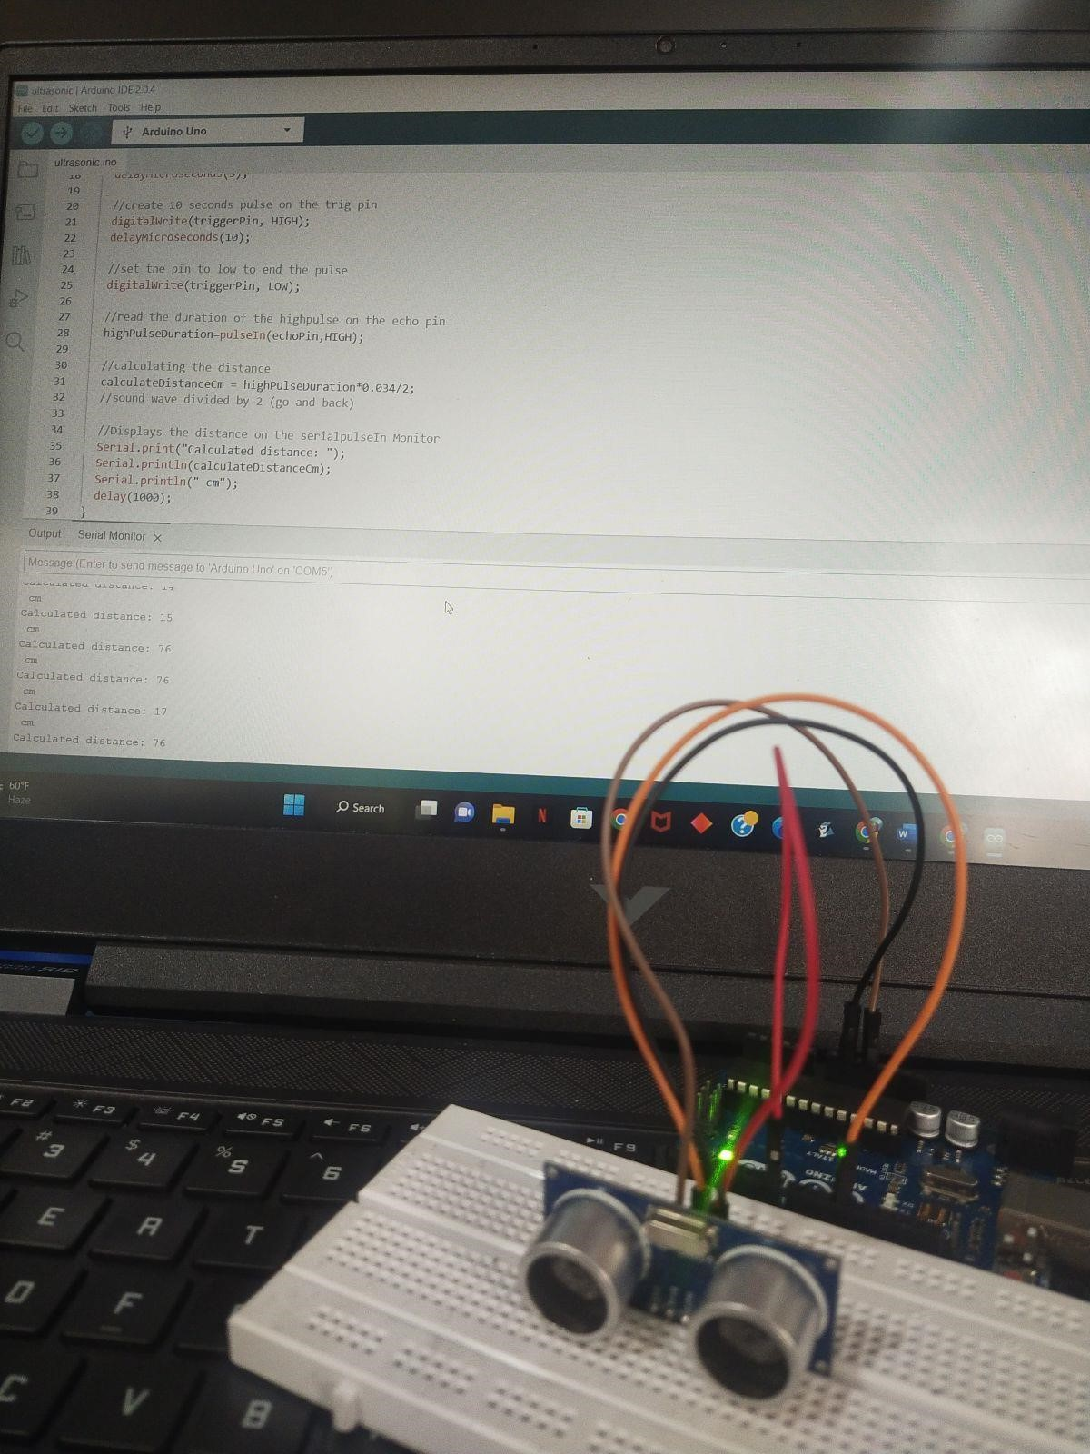

too large else ☺

### Activity 5.3: 1602 LCD Display

Fritzing Diagram

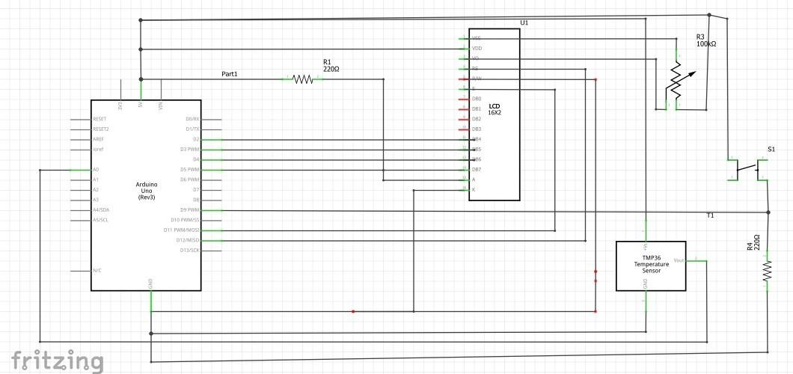

Arduino Program // C++ code

// Akriti Kumari Dev

// Student ID - 2329584

// include the library code:

#include <LiquidCrystal.h>

// initialize the library with the numbers of the interface pins LiquidCrystal lcd(12, 11, 5, 4, 3, 2); float value; int pushSwitch = 0; void setup() { pinMode(8,INPUT);

// set up the LCD's number of columns and rows:

lcd.begin(16, 2);

}

void loop() { value=analogRead(A0); pushSwitch=digitalRead(8); float degC = (value/1024.0)*500; float degF = (degC*1.8+32); if(pushSwitch == HIGH){

lcd.clear(); lcd.setCursor(0,0); lcd.print(degC); lcd.print(" C "); lcd.setCursor(0,1); lcd.print("NB_21"); delay(1000);

}

else{

lcd.clear(); lcd.setCursor(0,0); lcd.print(degF); lcd.print(" F "); lcd.print("NB_21"); delay(1000);

}

Take a picture of your LCD and include it here, please reduce the size and quality as it will be too large

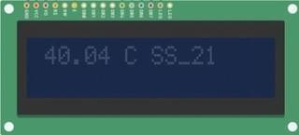

else ☺

Workbook 6

### Activity 6.1: PWM

Fritzing

|  |
| --- |
|  |

|  |
| --- |
| // C++ code  //  int rpin=3;  void setup()  {  Serial.begin(9600);  pinMode(rpin, OUTPUT);  }  void loop()  {  int val=analogRead(A0);  int bright=map(val,0,1023,0,255);  Serial.println(bright);  delay(1000);  analogWrite(rpin,bright);  } |

# Workbook 7

### Activity 7.1: 2 Arduinos – using Digital Pins

|  |
| --- |
|  |

Fritzing

|  |
| --- |
|  |

Arduino Program

### Activity 7.2: 2 Arduinos – using Serial I/O

|  |
| --- |
|  |

Fritzing

Arduino Program

|  |
| --- |
|  |

Workbook 8

### Activity 8.1: Stepper Motor Circuit Diagram

|  |
| --- |
|  |

Circuit Diagram

|  |
| --- |
|  |

### Activity 8.2: 2 Stepper Motors

|  |
| --- |
|  |

Arduino Program

Workbook 9

### Activity 9.1: Windscreen Wiper Code using Servos & Temperature Sensor

|  |
| --- |
|  |

Arduino Code

Individual Project (50%)

### Rationale

Throughout the module you have used a range of sensors and actuators with an Arduino to complete weekly tasks. For the mini project we would like you to research and create a small embedded project in an area of your choice, such as:

* Games
* Networking
* IT Security
* Systems Engineering • Smart Technology
* Artificial Intelligence

Previous projects have included a reaction game that gives a score depending on how fast you hit a button, this has buttons to restart the application, and an LCD to show scores, and information.

This project should be your own work, YOU MUST NOT COPY A PROJECT FROM THE INTERNET.

### Timescales

This project should be started around week 5 and continue until the deadline, when it will be submitted in the Portfolio.

Equipment

You are free to use Tinkercad, or your own kit.

### The Project

Step 1 produce adetailed description of your project.

This should clearly describe what you are intending to build and may contain some diagrams of how the sensor/switches input is to be processed by the Arduino. Then what kind of output is intended to be seen or heard by the user. Please mention any tools you intend to use.

Step 2 Circuit Diagram&Fritzing Schematic

You are required to produce a circuit diagram of your work showing any calculations you made, so these might be suitable resistor values for any LED’s you use. These calculations are covered on the module.

The circuit diagram should not be hand drawn but should follow the format of circuits from the module.

Step 3 A Program

You will need to write some software for this project and a listing of the code with suitable comments will need to be included.

Step 4 Testing

You will be required to produce some suitable test data that you would expect to be able to measure such as voltages, test code.

Once your prototype is complete you will be expected to test your circuit and compare the actual values to your initial test data, and comment on the results.

Step 5 Conclusions

You are required to write a summary of the work along with a short half page reflection on how you found the work.

Layout

The report should be suitably laid out for a report, using headings, references if required in Harvard style, and appendices used for any lengthy code. All diagrams should be produced on a PC, and handwritten work is not acceptable.

Marking

All sections carry equal marks.